ADMIN

[Email address]

Abstract

[Draw your reader in with an engaging abstract. It is typically a short summary of the document.   
When you’re ready to add your content, just click here and start typing.]

[Document title]

[Document subtitle]

# ABSTRACT

Many people are first exposed to code through web development, yet little is known about the barriers beginners face in these formative experiences. In this article, we describe a study of undergraduate students enrolled in an introductory web development course taken by both computing majors and general education students. Using data collected during the initial weeks of the course, we investigate the nature of the syntax errors they make when learning HTML and CSS, and how they resolve them. This is accomplished through the deployment of open HTML, a lightweight web-based code editor that logs user activity.

Our analysis reveals that nearly all students made syntax errors that remained unresolved in their assessments, and that these errors continued weeks into the course. Approximately 20% of these errors related to the relatively complex system of rules that dictates when it is valid for HTML elements to be nested in one another. On the other hand, 35% of errors related to the relatively simple tag syntax determining how HTML elements are nested.

We also find that validation played a key role in resolving errors: While the majority of unresolved errors were A present in untested code, nearly all of the errors that were detected through validation were eventually corrected. We conclude with a discussion of our findings and their implications for computing education.

# INTRODUCTION

**1.1 Introduction of domain**

**Web development** is the work involved in developing a website for the Internet (World Wide Web) or an intranet (a private network). Web development can range from developing a simple single static page of plain text to complex web applications, electronic businesses, and social network services. A more comprehensive list of tasks to which Web development commonly refers, may include Web engineering, Web design, Web content development, client liaison, client-side/server-side scripting, Web server and network security configuration, and e-commerce development. Among Web professionals, "Web development" usually refers to the main non-design aspects of building Web sites: writing markup and coding. Web development may use content management systems (CMS) to make content changes easier and available with basic technical skills. For larger organizations and businesses, Web development teams can consist of hundreds of people (Web developers) and follow standard methods like agile methodologies while developing Web sites. Smaller organizations may only require a single permanent or contracting developer, or secondary assignment to related job positions such as a graphic designer or information systems technician. Web development may be a collaborative effort between departments rather than the domain of a designated department.

There are three kinds of Web developer specialization: front-end developer, back-end developer, and full-stack developer. Front-end developers are responsible for behavior and visuals that run in the user browser, while back-end developers deal with the servers. Since the commercialization of the Web with Tim Berners-Lee developing the World Wide Web at CERN, the industry has boomed and has become one of the most used technologies ever.

**1.2 Introduction of Project Internship**

This is a Mass Mail Dispatcher where we send bulk mail to set of people at once. In this dispatcher we can use CSV file formats which can contain bulk E-mail Address and checks if given any E-mail is valid or invalid.

# EXISTING METHOD

Mass Mail Dispatcher is an existing method, but one without proper methodology. There is no adequate way to check whether the mail is valid and send the mass mail to those valid mail ids. We can’t find a single solution to both of these problems. If we check whether the mail ID is valid or not, there is no way to send the mail to the valid ids in bulk. We put all these together and came up with the idea of checking the bulk mail IDs and sorting the CSV into valid and invalid mail IDs. After sorting the valid mail ids, they can send the mail to those valid mail ids.

# PROPOSED METHOD WITH ARCHITECTURE

### Architecture:

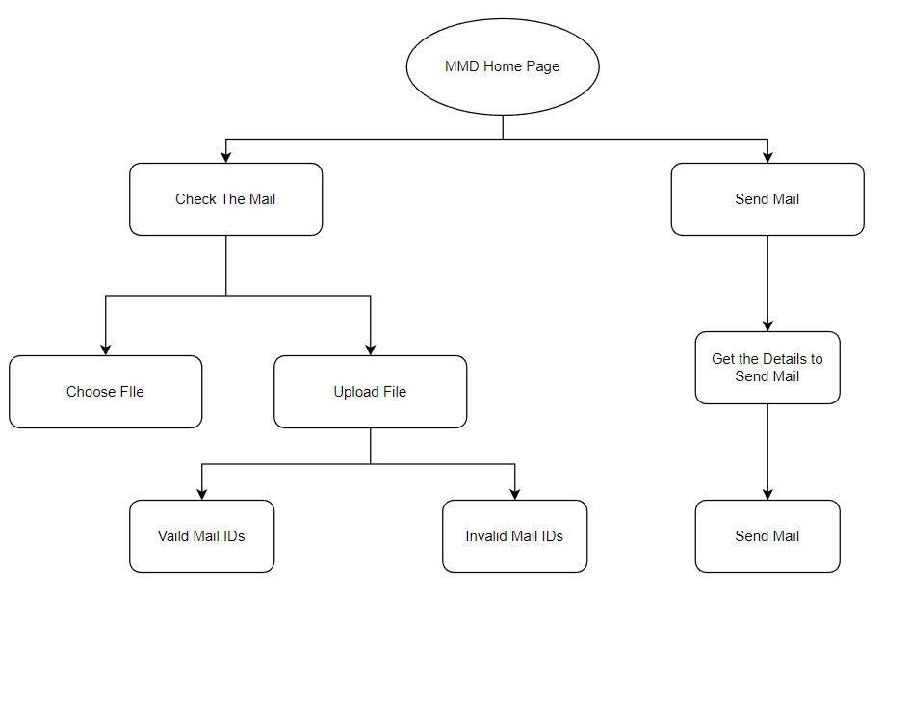

# METHODOLOGY

# IMPLEMENTATION

# CONCLUSION

Becoming a web developer is more than just working in the browser. Web developers write applications, and you are on that path. I encourage you to continue learning HTML, JavaScript, CSS, and Python. But when you're comfortable, branch out to other languages and platforms. The more exposure and experience you have with other languages and platforms, the better you'll become as a developer.